Grade 7 Accelerated · Unit 6 · Thread B · Day 2  Interior and Exterior Angles of a Triangle  Question Bank 6.T2 ANSWER KEY | Name  Date  Period

Show your work. Circle your final answer.
For questions 1 through 4, find the angle.
1. The third angle of a triangle with angles of 34° and 101°
45°
180 − 135.

2. The third angle of a right triangle with an angle of 27°
63°
180 − 90 − 27.

3. The exterior angle whose remote interior angles are 52° and 61°
113°
52 + 61.

4. The other remote interior angle, when an exterior angle is 118° and one remote angle is 47°
71°
118 − 47.

For questions 5 through 7, find x and the angles.
5. A triangle's angles are 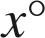, 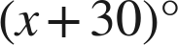 and 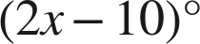.
x = 40; 40°, 70° and 70°
4x + 20 = 180.

6. An isosceles triangle's base angles are each 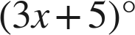 and the third angle is .
x = 20; 65° and 65°
6x + 10 + 50 = 180.

7. An exterior angle is ; its remote interior angles are 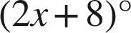 and .
x = 13; the exterior angle is 74°
6x − 4 = 2x + 48.

Choose one.
8. A triangle's angles are 30°, 70° and 80°. What is the exterior angle beside the 80°?
○ A. 80°
○ B. 280°
● C. 100°
○ D. 70°
C
30 + 70.

9. Which equation finds x when an exterior angle is 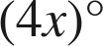 and its remote interior angles are  and 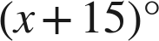?
○ A. 
● B. 
○ C. 
○ D.
B
Outside equals the two far ones: x = 20.

